Biggest Pitfalls In Medicare Advantage Plans (Part C)
There are a lot of good things about Medicare Advantage Plans. Many of them have low monthly premiums and offer prescription drug coverage. All Advantage Plans must provide at least the same coverage that Original Medicare offers, so they essentially bundle everything into one Plan. This sounds convenient, and some people believe it might be their best option. Keep in mind that even with an Advantage Plan, you still have to pay the Original Medicare Part B premium.

So What’s The Catch?
While there are certainly benefits to an Advantage Plan, there are also some significant pitfalls as well. The following are some of the most concerning ones:

Low Premiums, But High Co-Pays And No Max Out-Of-Pocket Costs
Many of the Advantage Plans with low or no monthly premiums have high out-of-pocket expenses. For example, one Advantage Plan has a $5,900 out-of-pocket maximum for in-network services. For out-of-network services, your out-of-pocket charges can reach as high as $10,000.

In case you aren’t aware, the out-of-pocket maximum is the amount of money you have to pay before your healthcare plan pays 100 percent of your costs. So if your out-of-pocket maximum is $5,900, you won’t have 100 percent coverage until you spend that $5,900. This means that you will be responsible for all co-pays and coinsurance until you reach that point. The out-of-pocket maximum resets each year.

This might not seem that important because many of the Advantage Plans have low co-pays, or even no co-pays, such as the cost of routine doctor’s visits and even visits with a specialist. However, there are certain circumstances that could end up costing you a considerable amount of money.

Example 1: You have a Medicare Advantage Plan. The premium is $25/month. The co-pay for acute inpatient hospital care is $270 per day for days 1-8. This means that for the first eight days you’re in the hospital, you will be charged $2,160. You qualify for Premium-free Part A. Additionally, you are responsible for whatever the Advantage Plan deductible is if there is one, as well as the Part B monthly premium..

Your friend has Original Medicare, and will be responsible for the Part A deductible, as well as twenty percent of their hospital bill for the entire stay. This is in addition to the Part B monthly premium.

See the graphic below for a visual representation of this example.

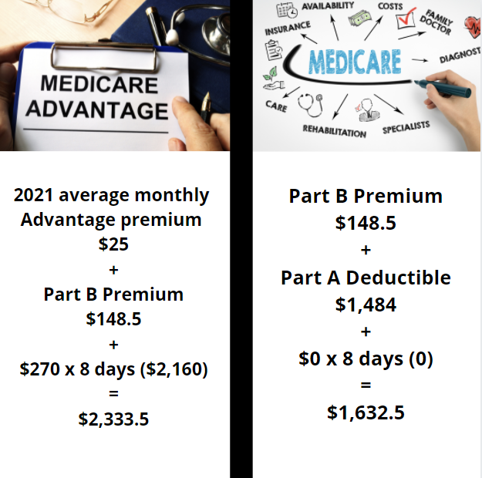

As you can see, if you have a Medicare Advantage Plan, your costs for this scenario would be significantly more than if you had Original Medicare, even without a Supplement Plan.

In some situations, there isn’t much of a price difference between Original Medicare and a Medicare Advantage Plan. However, you can usually cut costs by purchasing a Medicare Supplement Plan. See the example below.

Example 2: You have a Medicare Advantage Plan and need to enter a skilled nursing facility. With this plan, the co-pay for days 1-20 is $0. For days 21-100, the co-pay is $184 per day. Your friend has Original Medicare. Days 1-20 have a $0 co-pay, and days 21-100 have a co-pay of $185.50 per day. Your friend purchased a Supplement Plan to help cover the twenty percent that Original Medicare doesn’t cover. You both enter a skilled nursing facility for 60 days.

See the graphic below for a visual representation of example 2.

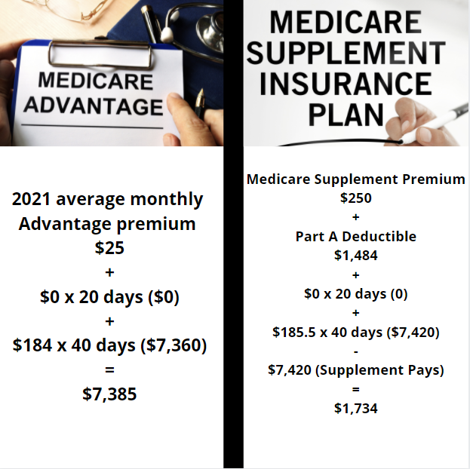

As you can see above, even if your Advantage Plan covers the Part A deductible and doesn’t have a deductible of its own, you’d still be far better off purchasing Original Medicare with a Supplement plan in this scenario.

More Pitfalls
Some other disadvantages of Medicare Advantage Plans that you might not be aware of include the following:

- Chemotherapy Drugs: With Medicare Advantage Plans, you are also responsible for twenty percent of the cost of all chemotherapy drugs until you hit your maximum out-of-pocket limit. When you’re dealing with something as serious and scary as cancer, the last thing you want to worry about is not having enough money to afford the life-saving drugs you need.
- Less Freedom: You do not have the same freedom with Advantage Plans as you do with original Medicare and Medicare supplement plans. For an advantage plan, you must go to their in-network doctors. The advantage plans must also accept all Medicare-eligible patients. As a way to deter very sick people or people who need more extensive medical care, the co-pays are often higher for more serious services.
- No Commonly Used Criteria: There’s no commonly used criteria to determine what is medically necessary, so sometimes Advantage Plans determine that something isn’t medically necessary, and they won’t cover the care even when you clearly need it. This is their way of limiting the amount of money they have to pay in healthcare costs, even for the people who really need it.
- Companies Become Insolvent: There have been instances of private insurance companies becoming insolvent or going out of business. When this happened in the past, the Advantage Plans stopped working. Coverage was terminated and appointments were canceled, leaving people to scramble for care that they desperately needed.
- Changing Doctors: Advantage Plans often change which doctors are eligible for in-network care, which can be really frustrating once you’ve built a relationship with a particular doctor who you can no longer use.

There are definitely some positive aspects to Medicare Advantage Plans, but it’s important to learn as much as possible about all of your options so you can do what’s best for your health and finances. If you signed up for an Advantage Plan but decide you want Original Medicare, you are permitted to switch. However, you won’t be able to do this until the open enrollment period, which means you could end up incurring very high medical costs for many months until you’re able to switch from the Advantage Plan to Original Medicare. If you ever have questions or need help signing up for a healthcare plan, don’t hesitate to reach out to us. We are here to help.

