CAMPERVANS - THE RIGHT CHOICE FOR YOUR NEXT TRIP?

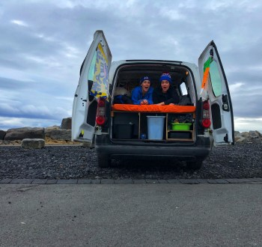

Until recently, I didn’t realize the popularity of campervans. We were planning our trip to Iceland and I was looking for an Airbnb to book in Reykjavik. Additionally, I was going to have to rent a car and then plan out all the rest of our Airbnbs along the way so that we had somewhere to stay. Alternatively, I was just going to rent the car and then figure out where to stay along the way – I figured there’d be hostels or hotels to stay in and since we weren’t going at a busy time, it would’ve probably been okay to do this.

While I was researching places to stay in Reykjavik and other parts of Iceland, an ad for campervan rentals popped up. I obviously knew that people traveled in RVs, but I had never really heard of traveling in campervans before, and I had certainly never thought of it for my own trip.

Once I saw that ad, I started looking into it and researching it more and it became a very appealing option for us. We wanted to travel around Iceland, not just stay in Reykjavik, so a campervan seemed perfect for us. We would have somewhere to sleep at all times and we would also have our rental car – it was 2-in-1 and would make the planning of our trip so much easier.

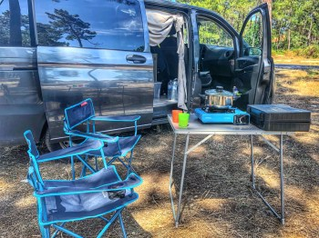

I didn’t fully know what to expect. I mean it’s not that complex– you show up and you live in a van and find places to sleep at night – but if you’ve never done it before, it can take some getting used to. We immediately fell in love with traveling this way, so much that it’s our dream to leave everything behind and travel Europe in a campervan! We love being able to go where we want when we want without planning anything in advance. We love being able to stop and eat lunch with some of the most amazing views ever! It’s just an incredible experience.

There are many different things to consider when deciding if you are going to rent a campervan, and then more to consider when deciding which one to rent.

You’ll need to think about price, what your plans are and where you want to travel, if you need a sink, shower, or a toilet, what size you would need your van to be, and more generally, you’ll need to decide if traveling and living in a van is appealing to you.

For us, it was easy to pick which campervan to rent. For our trip to Iceland, we basically wanted the cheapest one we could find but one that was obviously still reliable and wasn’t going to break down. We researched companies and found what seemed to be, and in my opinion is, a very reputable camper rentals company – Kukucampers.

We got the smallest, most basic model they had. It was a van with a bed and some storage in the back, basically. There was no toilet, no sink, no TV, and no bench or table for eating inside the van. Additionally, they provided us with a hot plate to cook our meals, as well as some plastic plates, bowls, cups, and utensils. The van was stocked with everything we were expecting and we didn’t have any significant complaints.

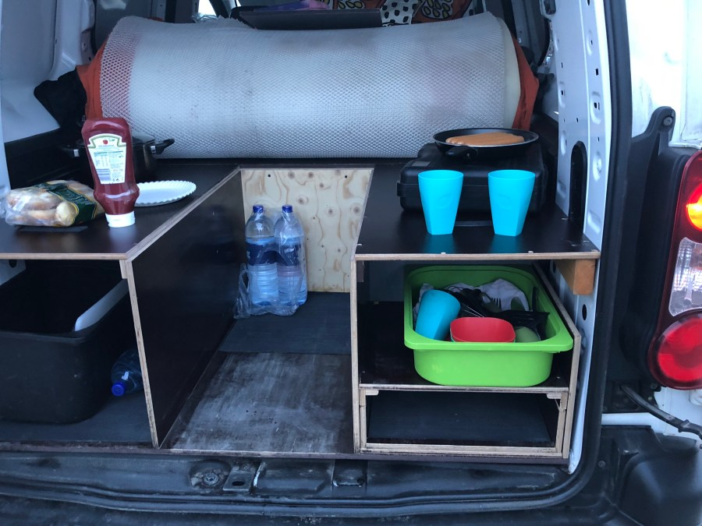
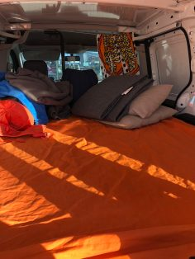

When you get a campervan this small, you can drive it pretty much anywhere. We had no issues driving it through the city and finding places to park because it’s essentially just a small van. If you rent something larger or end up with an RV rental, you would likely have some issues driving through cities with small streets.

That being said, there are also some limitations to small camper rentals. Because there wasn’t even a sink, anytime we needed to brush our teeth or wash our dishes or use water for anything, we needed to stop somewhere – a gas station, a hostel, or a campsite. There’s also no shower or no toilet, so again, this means you have to find somewhere anytime you need to use either of those things.

In most countries/cities with camper rentals, this won’t be an issue because there are so many hostels and designated campsites set up all over the country. In peak season it can be difficult because the places get so crowded, but generally you’ll be able to find somewhere if you plan accordingly.
When we went to Portugal and rented a campervan, we got one that was slightly bigger, but still considered a van and not an RV. The bed transformed into a bench, so we could sit and eat inside if we wanted to. Of course this wasn’t really necessary in Portugal because it was so warm outside. In Iceland, we would’ve preferred this type of van because it was below freezing throughout most of our trip in early March.

Our van in Portugal also had a sink, which was a huge bonus. We could wash our hands, wash our dishes, and brush our teeth without having to stop anywhere. There was even a hand held ‘shower’ in the back that you could use to rinse off if you didn’t feel like finding a designated campsite to stop at.
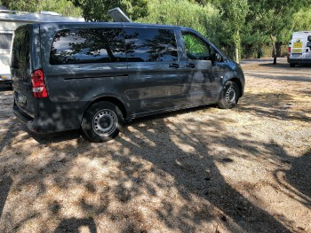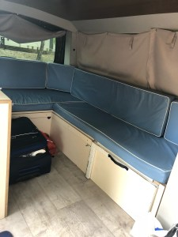

We again didn’t have a toilet, but we could’ve rented a portable one to keep in the van if we had wanted to. Personally, I’d prefer to stop and find a bathroom than keep a portable toilet in the van and have to empty it all the time.

The van we had was still small enough to drive through the small streets in the city, though just barely. If it had been any larger, it would’ve made traveling through the cities far more difficult.

We absolutely love the convenience of camper rentals and would travel that way forever if we could. We find the price of the campervan to be pretty on point with paying for accommodations and a rental car.

Whether you decide to get a campervan or not will certainly depend on where you’re traveling and what your plans are. If you plan on going to Iceland but all you’re doing is staying in Reykjavik, there’d really be no point in getting the campervan unless you just wanted the experience of living in a van for a little bit. If you want to travel around the country, camper rentals make a lot of sense.

If you need to shower every morning and style your hair, maybe a campervan isn’t for you. Or maybe you just need a big fancy RV! We saw a lot of people driving some pretty big campers that had bathrooms, and even TVs and satellite dishes.
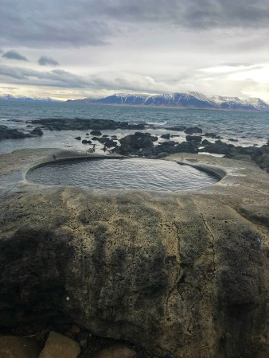

We also saw people traveling in camper rentals with young children, teenagers, and even dogs, so if this is something you want to do, you can make it happen, even if you’re traveling with a crowd or young children! You can definitely find the right van for you, you just need to figure out what you want and need.

We have friends who just have no interest and say there’s no way they’d ever want to travel like that, so if it’s not for you, that’s okay also. All I can say is if I could recommend one type of vacation to take, it would be a campervan vacation. I think it’s something everyone should experience, and I bet most people would end up enjoying it!

If you have any questions about campervan traveling, feel free to reach out and ask us some questions! We’d be happy to share our van experience with you and offer you some advice if you need it!

