This post will focus on things to do right in the center of Reykjavik, as well as places that are close enough for a day trip from Reykjavik; I’ll give you my 10 Top Things to do Near Reykjavik! There is so much to do in Iceland, so this post won’t even come close to covering everything. To see more information about attractions in Iceland outside of Reykjavik, see my other post!

1. THE GOLDEN CIRCLE
Before I went to Iceland, I did a TON of research to figure out the 10 top things to do near Reykjavik. The first thing to pop up 90 percent of the time was The Golden Circle. Problem was, I didn’t know much about Iceland and I didn’t know what the Golden Circle was!

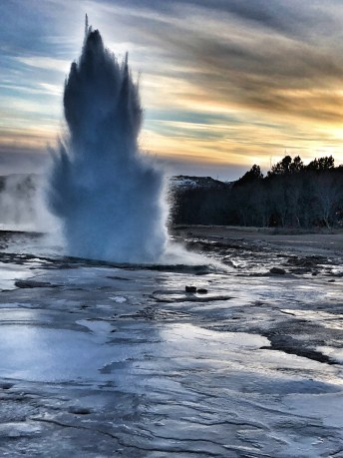
THE GOLDEN CIRCLE – GEYSIR

Let me make it easy for you: The Golden Circle consists of The Geysir geothermal area, Þingvellir National Park, and Gulfoss Waterfall.
The Geysir, called Strokkur, erupts every 4-8 minutes or so, so you’re pretty much guaranteed to see it when you go there. When it goes back to its resting phase, you can see the water start to heat up and bubble before it erupts again – it’s really cool to watch! Just make sure you stay within the ropes and don’t get too close – this water is way too hot to touch!
Þingvellir National Park is also a great place to go. We didn’t get to do as much there as I wanted to because it was too cold to do too much hiking, but it was still worth visiting.
The best thing we saw in the park was Oxarafoss (which you can read more about in my other Iceland post), my favorite waterfall in Iceland!

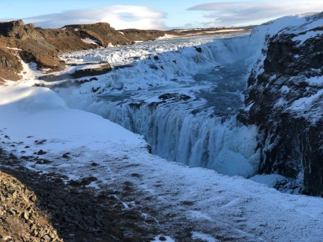
THE GOLDEN CIRCLE – GULFOSS WATERFALL

Gulfoss waterfall is also pretty amazing. This is one of the most popular waterfalls in Iceland, and when you see it, you’ll understand why. When we went, most of the waterfall was frozen – there was very little running water. It was still cool to see, but I’d also like to see it when it’s not frozen!
You can definitely see these 3 attractions in the same day – they are all close to each other and not too far outside of Reykjavik. The farthest is about an hour and a half outside of the city, but these 3 attractions are all within 40 minutes from each other.
My biggest piece of advice regarding the Golden Circle: if you have a car, do not take a tour! Go yourself! If you have rented a car, there is absolutely no reason to waste money on a Golden Circle tour. All of these attractions can be seen for free and are very easily accessible. You don’t have to walk far once you park your car, and there’s really no reason you can’t go on your own.

2. HALLGRIMSKIRKJA

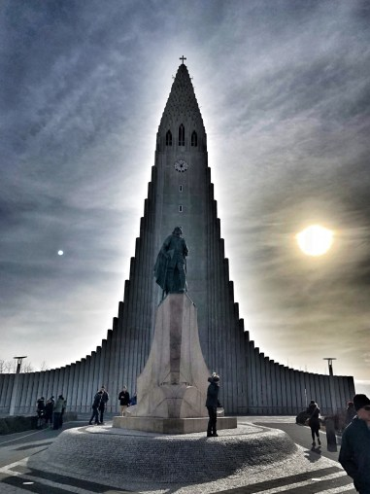
HALLGRIMSKIRKJA

Awesome looking church! It’s far more impressive on the outside than on the inside, in my opinion. That being said, it’s still worth going inside. If you want to spend a few dollars, buy a ticket and take the elevator to the top. The view is pretty awesome.
The church is right in the city, so if you’re there, definitely don’t miss this. When you see it in person, t’s such an impressive and powerful structure, and it’s quite unique.

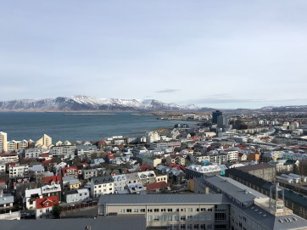

If you go inside, check out the organ – that was probably the coolest thing we saw inside of the actual church.
The line to take the elevator wasn’t too long, but it only holds 5 people at a time so it may take slightly longer than you think to get up to the top.

3. PERLAN MUSEUM

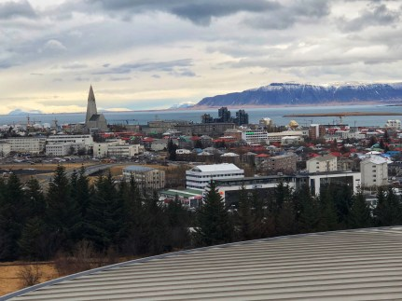
Perlan Museum Observatory Deck View

The Perlan Museum was interesting, and the view from the top of the observation deck is unbelievable. Pictures don’t really do it justice. We unfortunately didn’t get a chance to go into any of the real ice caves because of the weather, so I was far more excited than I should’ve been to go into the man-made ice cave at the Perlan Museum! Before going in, there are some amazing photographs to look at, so I highly recommend getting to your ‘ice cave tour’ a few minutes early to check those out.

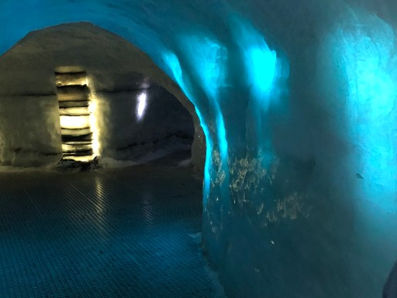
Perlan Museum Man-Made Ice Cave

It will cost you anywhere from $19-$39, depending if you want to see the ice cave and go to the top for the view. Had it not been a rainy day, I’m not sure we would have gone here at all, but I’m glad we did.
If you have a day to spend in Reykjavik and don’t want to do anything strenuous, this is a very good option. It is also a really great place to go if you are travelling with children.

4. SUN VOYAGER

Another very popular attraction in the list of 10 top things to do near Reykjavik is The Sun Voyager. The Sun Voyager is a sculpture that was created by Jon Gunnar Arnason. Though it looks like a viking ship, that was not what the intention was. Arnason intended it to be more of a dream boat, representing hope, progress, and freedom. Regardless of what it means, it’s definitely beautiful to look at and in the right light, you can get some pretty amazing pictures of it. Try to go early during sunrise or when the sun is setting – this should help you avoid a picture with a ton of tourists in it also.
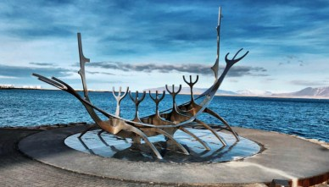
Sun Voyager

The Sun Voyager is in Reykjavik, just a few minutes walking from the Harpa Concert Hall. If you go see it in the right light, you’ll understand why it’s on the list of 10 top things to do!

5. KERIð

Kerið is a volcanic crater lake, and it’s very unusual if you’ve never seen a crater lake before. When we went, it was completely frozen solid – people were walking on the lake. When you get there, you do have to pay an entrance fee of about $3. Seems kind of weird to pay an entrance fee to walk over and see the volcanic crater lake, but we paid it so we could go down by the water/ice. Parking is right in front of the crater lake, so you don’t have to walk far, or really at all, to see it.
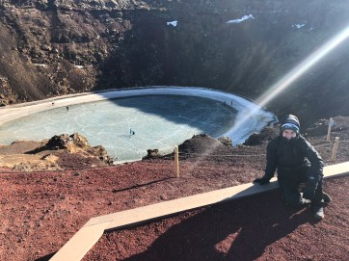
KERIð

This is a good place to stop during your Golden Circle day, as you could make it on the way from Reykjavik to Geysir and the other Golden Circle attractions. Once you’re there, walk down the stairs so you can see the actual lake – it’s not too steep of a walk.
You can also walk all the way around the edge of the rim and get different viewpoints of the crater lake from up top.

6. SELTJARNES PENINSULA

Another one of my 10 top things to do in Iceland is to go hang out at the Seltjarnes peninsula. This was probably my favorite place to go in Reykjavik. We would park facing the water, grill some food in our van, and eat with one of the best views I’ve ever seen. There’s also a lighthouse you can check out, though we couldn’t go inside. When it’s high tide, the path is covered, so just be aware of that! I didn’t see the northern lights here, but it’s apparently a good spot to try to catch them. There’s also a popular walking/biking path that leads all the way around the peninsula.

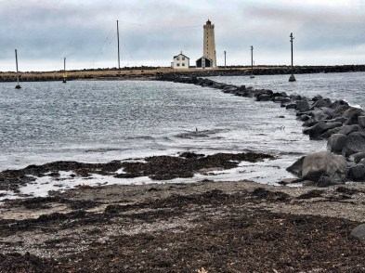
Seltjarnes Peninsula Lighthouse

The absolute best part of Seltjarnes Peninsula is the little geothermal foot-bath…it is incredible. Even though it was freezing out, we did take off our shoes and socks and soak our feet in the bath for a few minutes. The view is unreal, and just sitting in freezing weather soaking our feet in this naturally warm foot-bath was such a unique experience.

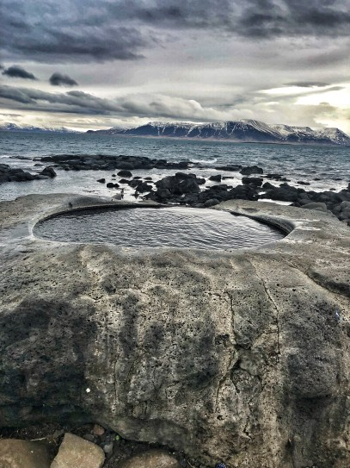
Seltjarnes Peninsula Footbath – Kvika

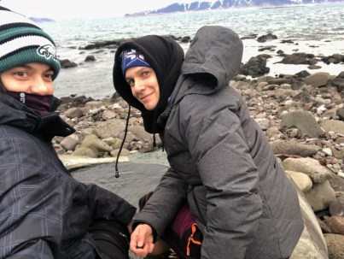

Drive toward the end of the peninsula – once you see what looks like an abandoned shack, you should park and go find the thermal foot-bath! It’s pretty much right in front of that building – if you didn’t know it was there, you could easily miss it. When we went, we were the only people there, which was great for us since it’s too small to share! It’s one of those little treasures of Iceland that is so easy to miss, but so magical if you take the time to find it.
DON’T MISS THE FOOT- BATH! IT’S AWESOME.

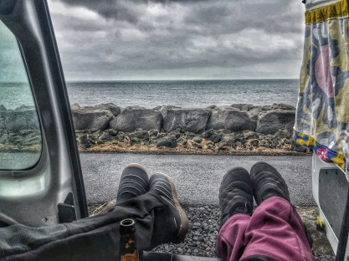
Seltjarnes Peninsula

7. KRYSUVIK AND GUNNUHVER GEOTHERMAL AREA

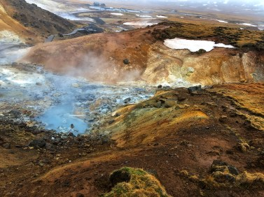
Krysuvik Geothermal Area

These two geothermal areas were really spectacular- another trip we may not have made had the weather been better. We originally wanted to hike and see a different hot spring river that you can actually bathe in, but it’s a far hike and it was freezing and raining off and on. Krysuvik is a must see. Gunnuhver can be skipped if you don’t have time.

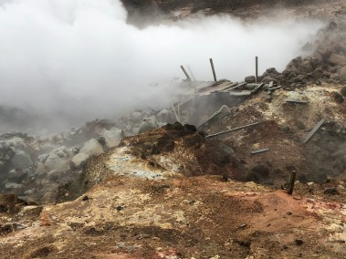
Gunnuhver Geothermal Area

There are hot springs everywhere – you can see them boiling, and the colors you will see on this trip are surreal. The water is this milky blue color, and the contrast of all the reds and greens around it is just amazing. As soon as we got there, it felt like we had landed on a different planet. Krysuvik (pictured far left) was larger and more interesting. Seeing them both is a bit redundant, but I strongly suggest that you go to Krysuvik. It’s about 25-30 minutes outside of Reykjavik.

8. HEAD DOWNTOWN
We only went into the actual downtown part of Reykjavik once, but it was adorable. There are so many restaurants and bars, and countless little shops you can visit. There are shops that sell souvenirs and trinkets, and other stores that sell hand made authentic wool clothing which was really cool to see.

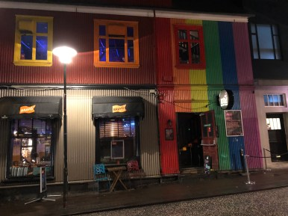
Downtown Reykjavik

We walked around and bought some souvenirs, but we didn’t eat or drink anywhere in town. A cocktail was somewhere around $15-$20 and dinner would have been really expensive, so we just went downtown to walk around for a bit, then bought a couple beers and grilled in the van for dinner!

9. JUST. START. DRIVING.

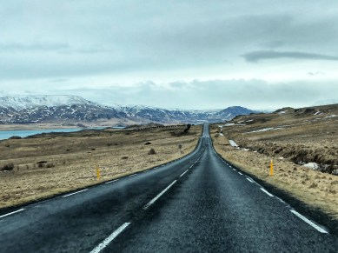
Reykjavik Landscape

Honestly, one of my favorite things to do in Iceland was to just drive around and look at the scenery. Every picture I took looked like an actual postcard – it’s amazing. The water and the volcanic mountains and the glaciers – it’s all breathtaking. I could fill a list of 10 top things to do with just pictures of us driving around Iceland. On our trip to Krysuvik, we did a lot of driving shortly outside of Reykjavik and I highly recommend it.

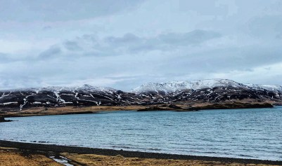
Reykjavik Landscape

The water in Iceland is mesmerizing, especially in the winter. Parts of it would be light blue, parts dark blue, half frozen….I seriously can’t say enough how much I loved just driving around.
If you have a rainy day, or even if you don’t, take a couple hours and just. start. driving. I promise you won’t be disappointed. Just don’t forget your camera!

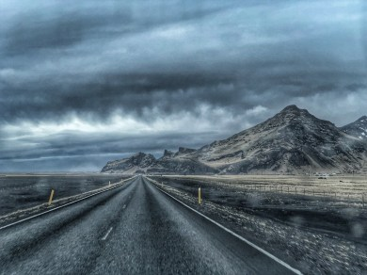
Iceland Landscape

10. FIND THOSE NORTHERN LIGHTS!

Obviously this list of 10 top things to do near Reykjavik wouldn’t be complete if it didn’t mention the Northern Lights! I would love to have a beautiful, magical picture of the northern lights to show you, but we didn’t exactly plan that out too well. The only thing we had were our iPhones, so the only way to take a picture of the northern lights was with an iPhone app – so this picture will have to do
I’ll admit it – when I first chose to go to Iceland, the main reason was because I knew it was a good spot to see the Northern Lights. I don’t know how it came into my head or why, but I started googling “where can I see the Northern Lights in March” and Iceland was a good choice. There were direct flights, flights were cheap, and it looked like there was a lot of other interesting stuff to do there. I’m SO happy we chose Iceland. Our trip would have been fantastic even if we hadn’t seen the Northern Lights. We were sitting in our van on the last night, and they decided to appear! We were ecstatic, to say the least.

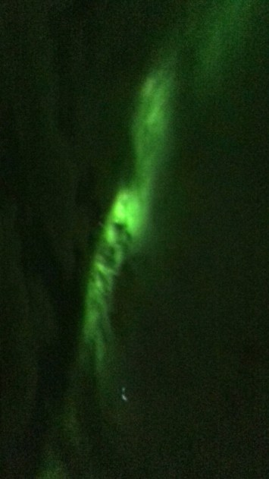
Northern Lights in Iceland

To see the Northern Lights in the Reykjavik area – go to the Grotto Lighthouse on the Seltjarnes Peninsula, or drive to Þingvellir National Park. Before you get to the visitor’s center, there are a lot of good places to pull off where you can sit and wait for them!

Iceland is truly an amazing place, and this post doesn’t even begin to cover all of the things you can do in Iceland. We still have more than half the country to explore! If you want to see what else we did in Iceland and what I recommend, check out my other post!

See the interactive map below for some of the main attractions in Iceland – some of them we visited and I talked about in this post and my other post – some of them we didn’t get a chance to visit, but they are very popular and we would have gone if we had time/had the weather permitted!

